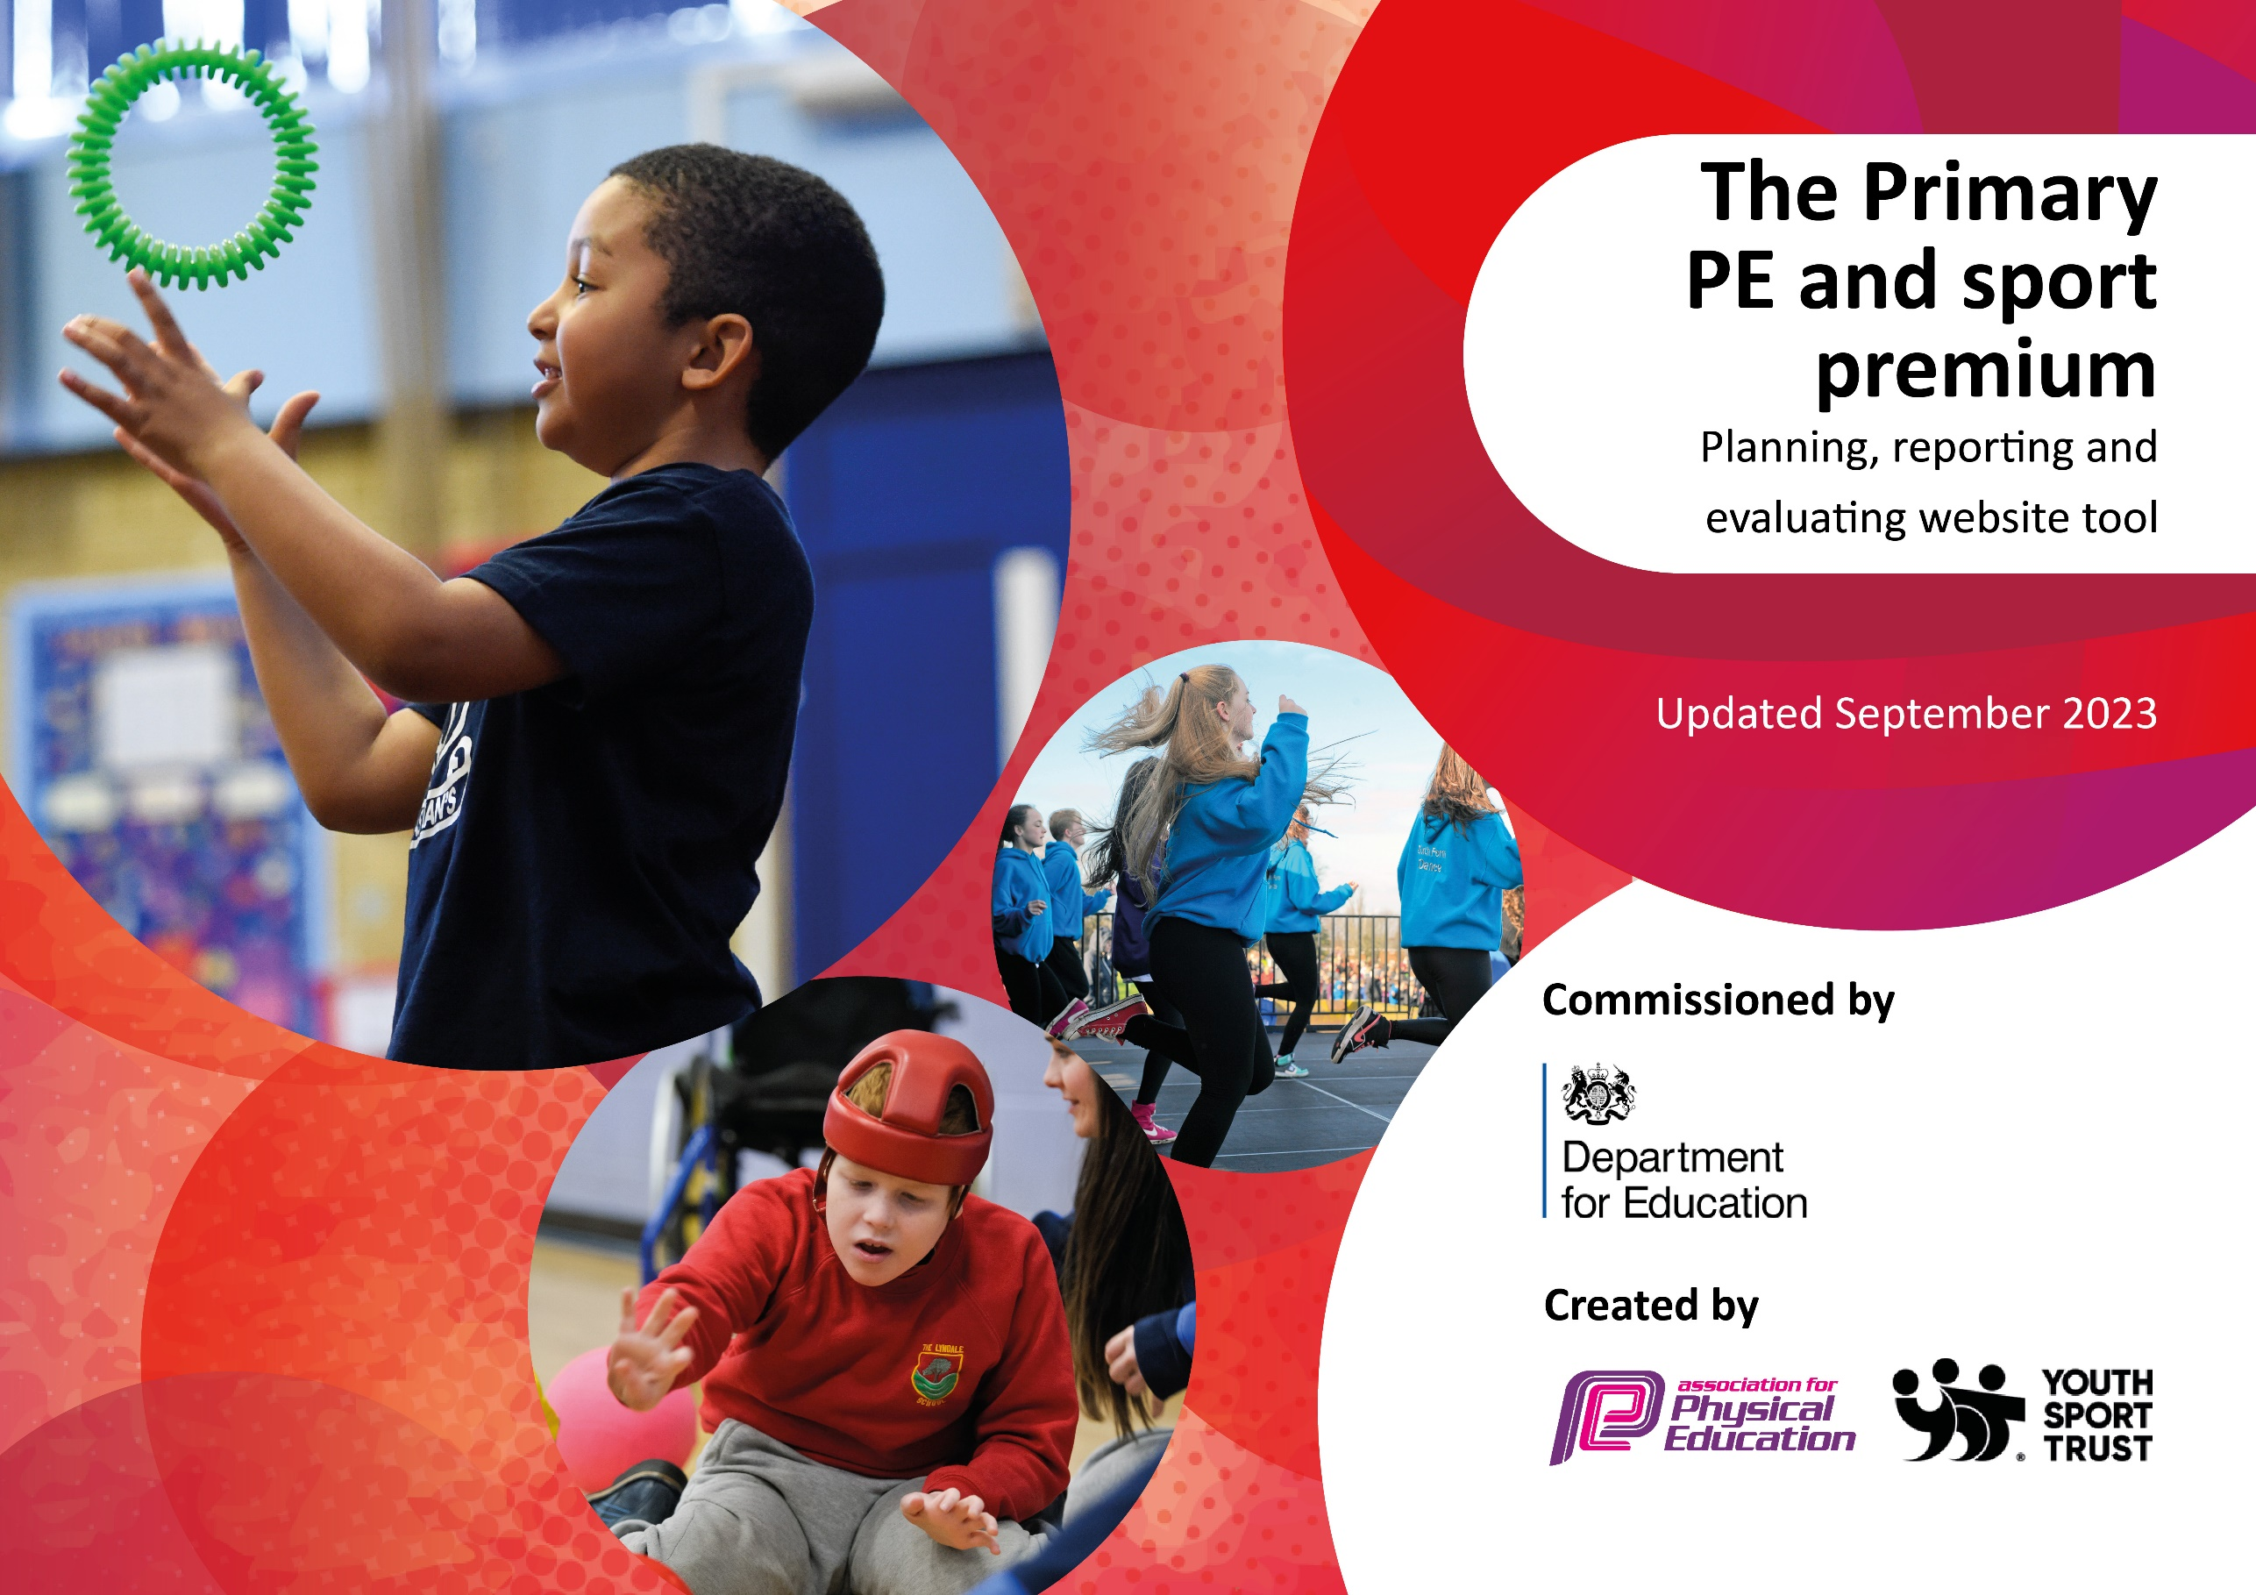

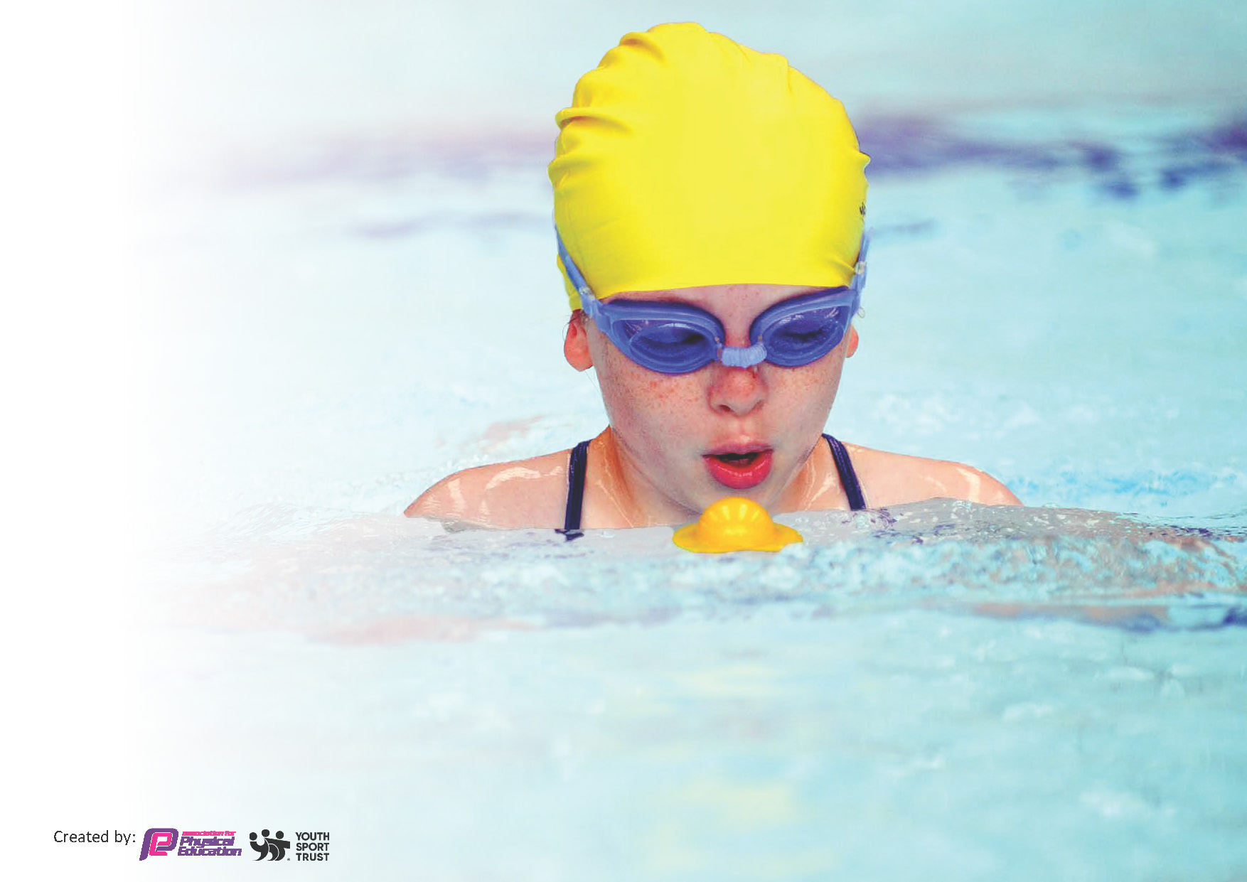
This template can be used for multiple purposes:
by:
- It enables schools to effectively plan their use of the Primary PE and sport premium
- It helps schools to meet the requirements (as set out in guidance) to publish information on their Primary PE and sport premium
- It will be an effective document to support Ofsted inspections enabling schools to evidence progress in Physical Education (PE) and evidence swimming attainment, which forms part of the PE National Curriculum. We would recommend schools consider
the Intent, Implementation and Impact of any spend, as examined within the Education Inspection Framework.

It is important that your grant is used effectively and based on school need.

Schools must use the funding to make additional and sustainable
improvements to the quality of the PE, School Sport and Physical Activity (PESSPA)
they offer. This means that you should use the Primary PE and sport premium to:

- Build capacity and capability within the school to ensure that improvements made now will benefit pupils joining the school in future years
- Develop or add to the PESSPA activities that your school already offers.

The Primary PE and sport premium should not be used to fund capital spend projects; the school’s core budget should fund these. Further detail on capital expenditure can be found in the updated Primary PE and sport premium guidance.

The Primary PE and sport premium guidance, outlines 5 key priorities that funding should be used towards. It is not

necessary that spending has to meet all the key priorities, you should select the priorities that you aim to use any funding towards.

Although completing this template is not a requirement for schools, schools are required to publish details of how they spend this funding. Schools must also outline what the impact this funding has had on pupils’ PE and sport participation and attainment and how any spending will be sustainable in the future. All funding must be spent by 31st July 2024.

The Department for Education has worked closely with the Association for Physical Education (afPE) and the Youth Sport Trust (YST) to develop this template and encourages schools to use it. This template is an effective way of meeting the reporting requirements of the Primary PE and sport premium.

We recommend you start by reflecting on the impact of current provision and reviewing your previous spend.

Key priorities and Planning for (2026/2027)
This planning template will allow schools to accurately plan their spending.

Action – what are you planning to do | Who does this action impact? | Key indicator to meet | Impacts and how sustainability will be achieved? | Cost linked to the action
Continue active breakfast club.  New equipment purchased to enable teachers to deliver all aspects of the school PE offer and curriculum.  Sign up to a new SLA with Education Enterprise.  Develop movement skills in Nursery/EYFS | Pupils who take part.  Teaching assistants who assist with breakfast club on rota.  Parents whose children attend breakfast club.  All children  Teaching Staff  All KS2 children  EYFS/KS1 | Key indicator 1 -The engagement of all pupils in regular physical activity – the Chief Medical Officer guidelines recommend that all children and young people aged 5 to 18 engage in at least 60 minutes of physical activity per day, of which 30 minutes should be in school.  Key indicator 2: The profile of PESSPA being raised across the school as a tool for whole school improvement  Key indicator 4: Broader experience of a range of sports and activities offered to all pupils  Key indicator 5: Increased participation in competitive sport | More children turning up to school early and heaving a positive start to the day, getting breakfast and doing 30 minutes of extra physical exercise per day.  Safeguarding for staff numbers.  Becoming more and more popular every year.  Audit done of sport equipment available.  Replenished based on the needs, linked to PE lessons throughout the year.  Teachers able to continue delivering high quality PE lessons with equipment needed.  Giving children the opportunity to practice skills learnt in school, in inter-school competitive fixtures with a chance of progression to county finals. Clear path of progression outlined.  Education Enterprise FUNdamental development sessions signed up to on SLA | £3900 estimated for JG Sport Coaching breakfast club provision  £800  £890  £700

Improve gross motor skills with a particular focus on biking in EYFS/KS1  Staff CPD – Outdoor Adventurous Education | EYFS/KS1  KS2 staff | Key indicator 1 -The engagement of all pupils in regular physical activity – the Chief Medical Officer guidelines recommend that all children and young people aged 5 to 18 engage in at least 60 minutes of physical activity per day, of which 30 minutes should be in school.  Key indicator 3: Increased confidence, knowledge and skills of all staff in teaching PE and sport | Children to become more confident in riding bikes and co-ordination needed.  Staff being trained with the skills to lead effect OAA PE sessions. | £480 for 1 term  £160

Key achievements 2025-2026
This template will be completed at the end of the academic year and will showcase the key achievements schools have made with their Primary PE and sport premium spending.

Activity/Action | Impact | Comments

Head Teacher: | Claire Sim
Subject Leader or the individual responsible for the Primary PE and sport premium: | Carl Vincent (PE Co-Ordinator and Deputy Headteacher).
Governor: | Neil Boyd
Date: | 21.09.26

