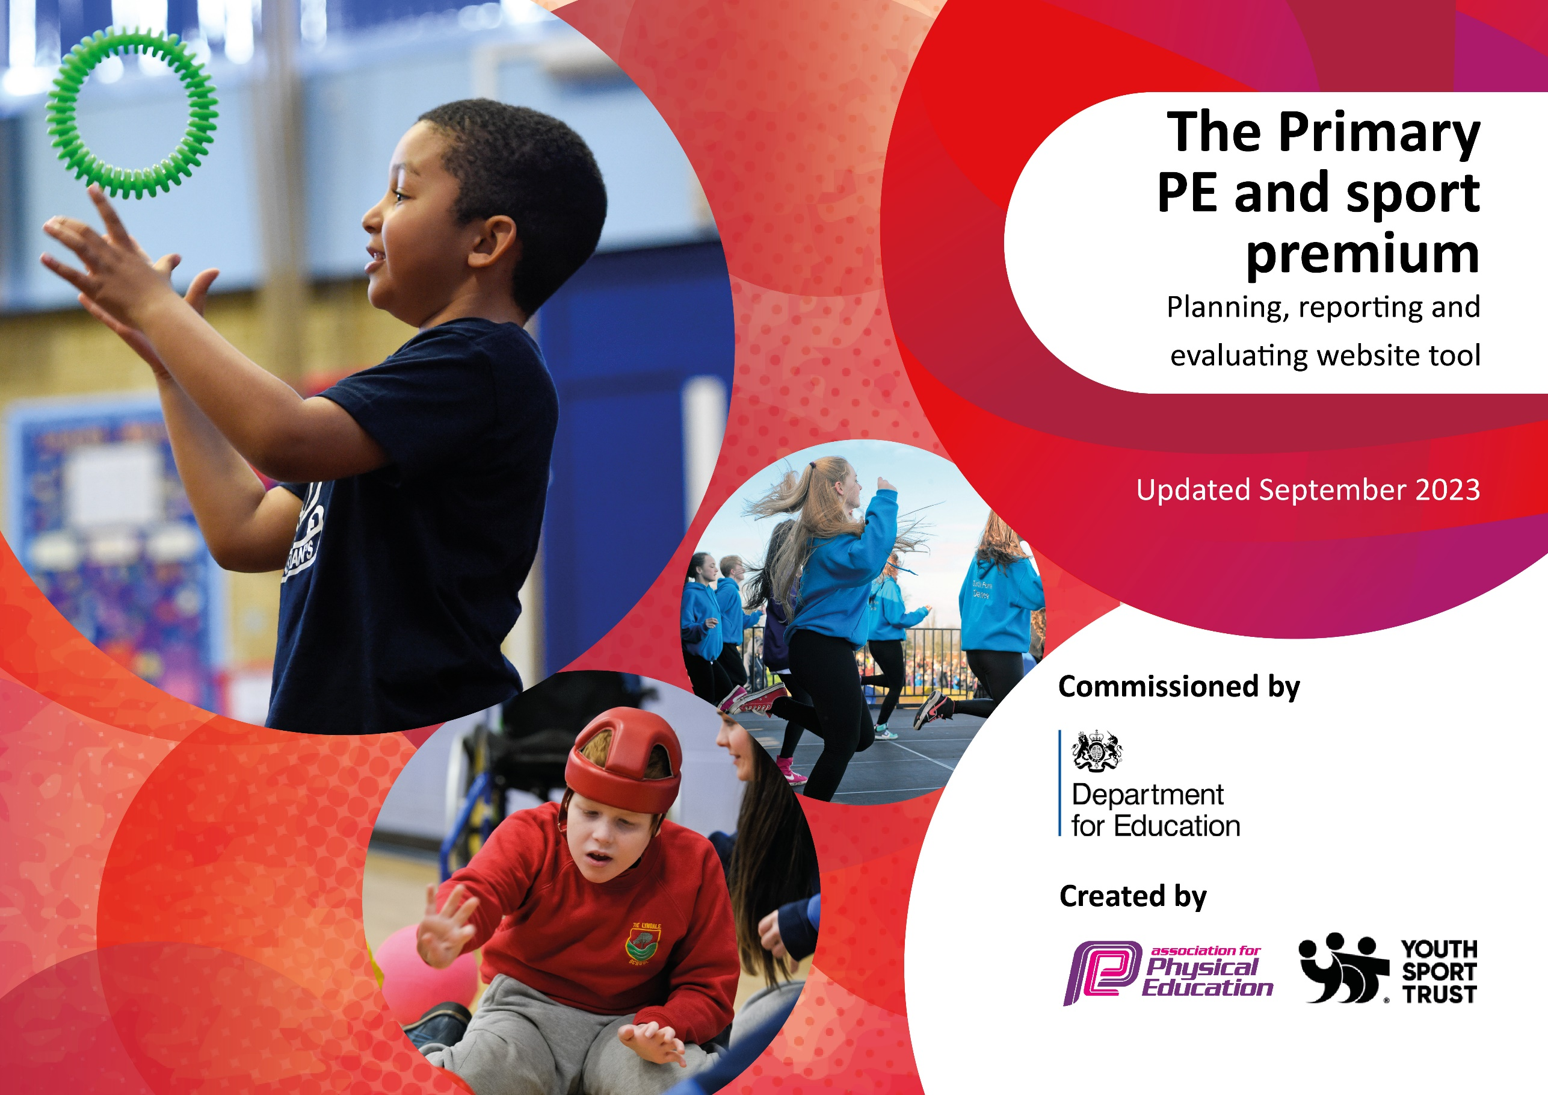

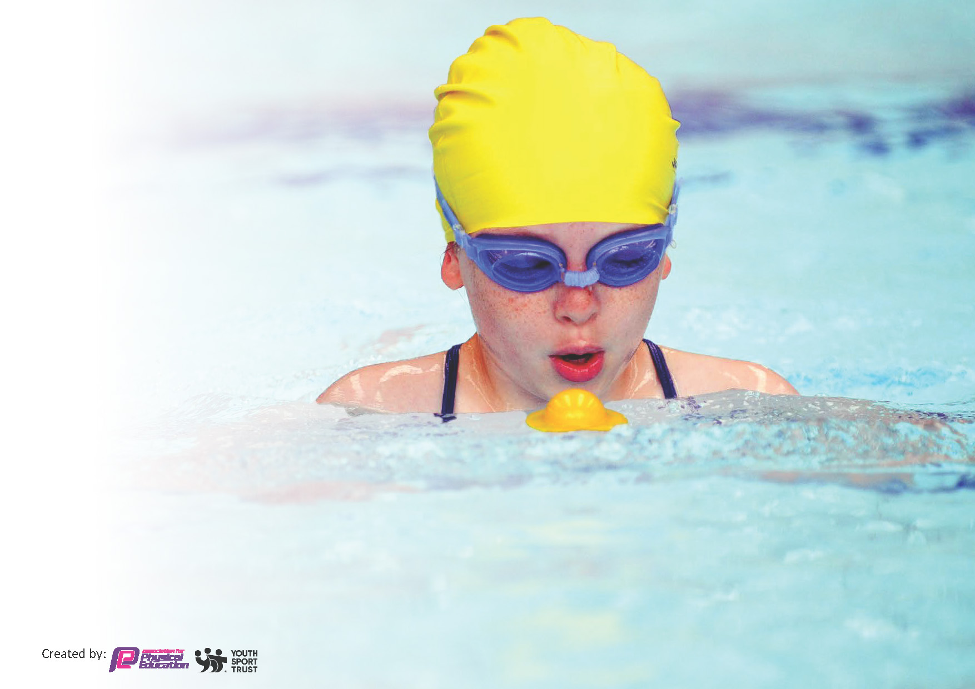
This template can be used for multiple purposes:
by:
- It enables schools to effectively plan their use of the Primary PE and sport premium
- It helps schools to meet the requirements (as set out in guidance) to publish information on their Primary PE and sport premium
- It will be an effective document to support Ofsted inspections enabling schools to evidence progress in Physical Education (PE) and evidence swimming attainment, which forms part of the PE National Curriculum. We would recommend schools consider
the Intent, Implementation and Impact of any spend, as examined within the Education Inspection Framework.

It is important that your grant is used effectively and based on school need.

Schools must use the funding to make additional and sustainable
improvements to the quality of the PE, School Sport and Physical Activity (PESSPA)
they offer. This means that you should use the Primary PE and sport premium to:

- Build capacity and capability within the school to ensure that improvements made now will benefit pupils joining the school in future years
- Develop or add to the PESSPA activities that your school already offers.

The Primary PE and sport premium should not be used to fund capital spend projects; the school’s core budget should fund these. Further detail on capital expenditure can be found in the updated Primary PE and sport premium guidance.

The Primary PE and sport premium guidance, outlines 5 key priorities that funding should be used towards. It is not

necessary that spending has to meet all the key priorities, you should select the priorities that you aim to use any funding towards.

Although completing this template is not a requirement for schools, schools are required to publish details of how they spend this funding. Schools must also outline what the impact this funding has had on pupils’ PE and sport participation and attainment and how any spending will be sustainable in the future. All funding must be spent by 31st July 2024.

The Department for Education has worked closely with the Association for Physical Education (afPE) and the Youth Sport Trust (YST) to develop this template and encourages schools to use it. This template is an effective way of meeting the reporting requirements of the Primary PE and sport premium.
Review of last year’s spend and key achievements (2024/2025)

We recommend you start by reflecting on the impact of current provision and reviewing your previous spend.

Activity/Action | Impact | Comments
Key Indicator 1 (£6000 allocated)  1. Encourage children to take part in all PE sessions without worrying about kit and avoiding stereotypes.  2. More pupils meeting their daily physical activity goal, more pupils encouraged to take part in PE and Sport Activities at times other than PE and after school clubs  3. Higher percentage of Y6 children to achieve swimming standards then predicted last year.  4. Sport Kings to deliver active breakfast clubs daily, available to all children.  Key Indicator 2: (£600 allocated)  1. Using equipment to raise the profile of sport. Improving equipment, engagement, enjoyment and participation.  2. PESSPA lead to run sessions to train sports/break leaders.  Key Indicator 3: (£1000 allocated)  1. Staff to be confident with progression of skills throughout PE element of PESSPA and be confident in using the relevant assessment criteria.  2. Gaps to be plugged in staff knowledge/sports where staff lack confidence (gymnastics/dance).  3. Differentiation to at least two levels to now be shown in lesson delivery, based on planning from peplanning.org - CPD to be arranged.  4. PE planning website subscription continued.  Key Indicator 4: (£6000 allocated)  1. All children to access either a inter-school festival or represent the school in a league fixture throughout the course of the year.  2. More able children to represent the school in Level 2 competitions.  3. Children to access active break and lunch times.  Key Indicator 5: (£500 allocated)  1. Increase the number of SEN children who are able to access competitive sport through leagues and Level 2 competitions throughout the year.  2. Children to have suitable equipment and kit to access and take part in competitive sport safely, replaced yearly if needed. | Key Indicator 1 (£6650 spent)  New kit was bought to replenish those kits that were old/worn. Children take part in PE regularly and there are no children missing out on lessons through lack of kit or inappropriate kit. The children love PE and I gives them a collective identity and encourages them all to have a go in lessons.  Children are becoming more aware of what it means to live a ‘healthy lifestyle’, and are beginning to talk more about it – physical literacy is improving and more children can talk about diets, food, activity and exercise.  At its most popular mark there has been a 9.63% increase in the number of children who access active breakfast club (27% of the school accessed in 23-24 compared to 36.63% in 24-25). School have been able to keep the costs low (50p per child) to attend breakfast club, due to investment from Sport Premium and the number of children who take up the offer.  Key Indicator 2: (£725 spent)  Replenished equipment means better access to lessons and teachers can teach with more confidence, leading to better engagement and better lessons which facilitate learning.  Key Indicator 3: (£1158 spent)  Medium term plans now reflect what is expected at the end of each block of work. PE weekly planning is covered by PEplanning.org subscription. Gives detailed lessons plans and STEP adaptations. Teacher confidence has greatly improved in delivering lessons. Staff are generally very good and confident in assessing and delivering quality PE lessons – see data and scores from staff audits.  Key Indicator 4: (£4919 spent)  Engagement in festivals and leagues has increased. All children throughout the year have represented the school in either a festival or a league competition against other schools at a different venue.  Key Indicator 5: (£670 spent)  SEND children accessed Multi-Skills School Games competition last year as a trial event. Buses were very expensive last year, cut back next year by having more staff with necessary insurance and increasing parental links. Children were very keen and the festival will continue next year. More children SEN children are accessing some form of after school provision as well, compared to last year (22-23). 58.33% of SEN children at school attended at least one Sport competition for school this year.

Key priorities and Planning for (2025/2026)
This planning template will allow schools to accurately plan their spending.

Action – what are you planning to do | Who does this action impact? | Key indicator to meet | Impacts and how sustainability will be achieved? | Cost linked to the action
Continue active breakfast club.  Arrange CPD for activ award  Improve lunchtime provision offer.  Sensory circuits up and running in school for those with SEN and identified needs.  Break and lunch sports offer improved.  Develop curriculum offer for teaching skills associated with OAA and orienteering so it becomes embedded as part of the curriculum.  New equipment purchased to enable teachers to deliverall aspects of he school PE offer and curriculum.  Sign up to a new SLA with Education Enterprise.  Develop sensory circuit offer to SEN children, as mentioned in SIP. School has large percentage of SEN children, especially ADHD and Autistic/sensory diagnoses. | Pupils who take part.  Teaching assistants who assist with breakfast club on rota.  Parents whose children attend breakfast club.  Pupils who take part in PE.  Teachers who deliver sessions.  Pupils who take part in PE  Staff who deliver PE.  Pupils  Staff | Key indicator 1 -The engagement of all pupils in regular physical activity – the Chief Medical Officer guidelines recommend that all children and young people aged 5 to 18 engage in at least 60 minutes of physical activity per day, of which 30 minutes should be in school.  Key indicator 2: The profile of PESSPA being raised across the school as a tool for whole school improvement  Key indicator 3: Increased confidence, knowledge and skills of all staff in teaching PE and sport  Key indicator 4: Broader experience of a range of sports and activities offered to all pupils | Breakfast club has become sustainable and embedded in school after 2 years. Numbers continue to rise as we keep costs down (50p) to allow all children to attend. Maximum of 36.63% children attending last year (24-25), as apposed to 27% the previous year (23-24).  Sensory circuits o be timetables into school day and embedded throughout the course of the year. CPD from County Durham already undertaken. Investment in resources and equipment so children of varying different needs can access.  Based on staff audits, CPD to be arranged through county/SLA based on teaching needs. Improve confidence and quality of lessons.  Children to access arrange of different sporting opportunities outside of school and SEN children to be given | £6500 estimated  £5850 estimated for SportKing breakfast club provision.  £650 for additional staff training for activ break and lunchtimes, including CPD and equipment.  £1000 – budgeted  Equipment and resources for those with high needs to access physical activity daily.  £160  £5500 - estimated  £4550 for new SLA with Education Enterprise.  £1000 for equipment for sensory circuits for SEN children and equipment.

Sign up to the school competition element of SLA agreement with Education Enterprise.  Provide bus transport to get children to larger events (cross country, athletics, swimming gala), with aim of achieving bronze award for school. | Pupils  Staff | Key indicator 5: Increased participation in competitive sport | Limited need this year, but will be needed for larger events such as Cross Country and Athletics so all children can compete. | £1000- estimated.  £1000 for transport, school sport competitions are free through SLA offer.

Key achievements 2024-2025
This template will be completed at the end of the academic year and will showcase the key achievements schools have made with their Primary PE and sport premium spending.

Activity/Action | Impact | Comments
Increased number of children accessing activ breakfast club before school.  SLA  CPD – Teacher confidence. | More children accessing active breakfast club has meant more children coming into school and having breakfast while also starting the day with some form of physical activity (27% up to 36.63%). This has improved children’s behavior in class over the last 2 years which we have been offering it. We have been able to keep the cost of attending the breakfast club low (50p per day) which has meant more of our families can access it as we are in a socially deprived area.  Opportunities and success at school sport has increased. More children accessing sporting competitions and experiencing and learning with how to deal with winning and losing – focus on including SEN children in physical activity and school sport next year.  Teacher confidence has significantly improved (as shown through staff audits). Leading to more success improved assessment data and enjoyment in PE and physical literacy.

Swimming Data 2023 - 2024
Meeting National Curriculum requirements for swimming and water safety.
Priority should always be given to ensuring that pupils can perform safe self-rescue even if they do not fully meet the first two requirements of the National Curriculum programme of study

Question | Stats: | Further context  Relative to local challenges
What percentage of your current Year 6 cohort can swim competently, confidently and proficiently over a distance of at least 25 metres? | 84.62%* (11 out of 13 children)  Estimated as cannot login to Swimphony due to a problem with their authentication code system – they are working on problem  *Subject to change
What percentage of your current Year 6 cohort can use a range of strokes effectively [for example, front crawl, backstroke, and breaststroke]? | 76.92%* (10 out of 13 children)  Estimated as cannot login to Swimphony due to a problem with their authentication code system – they are working on problem  *Subject to change

What percentage of your current Year 6 cohort are able to perform safe self-rescue in different water-based situations? | 92.31%* (12 out of 13 children)  Estimated as cannot login to Swimphony due to a problem with their authentication code system – they are working on problem  *Subject to change
If your schools swimming data is below national expectation, you can choose to use the Primary PE and sport premium to provide additional top-up sessions for those pupils that did not meet National Curriculum  requirements after the completion of core lessons. Have you done this? | Yes/No
Have you provided CPD to improve the knowledge and confidence of staff to be able to teach swimming and water safety? | Yes/No

Signed off by:

Head Teacher: | Claire Sim
Subject Leader or the individual responsible for the Primary PE and sport premium: | Carl Vincent (PE Co-Ordinator and Deputy Headteacher).
Governor: | Neil Boyd
Date: | 14.07.25

