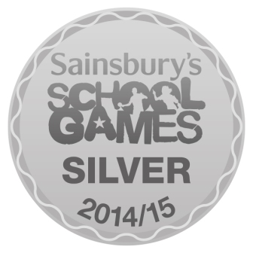

# **Sunnybrow Primary School**

Mrs S Binks Head Teacher

Sunnybrow, Crook, Co. Durham, DL15 0LT



Tel/ Fax: 01388 746413

[sunnybrow@durhamlearning.net](mailto:sunnybrow@durhamlearning.net)

Website - www.sunnybrowprimaryschool.org.uk

# ***Newsletter***

*Issue No: 313 15/05/2019*

**SATs**

Year 6 and Year 2 have been doing SATs all week and we are really proud of their hard work and positive attitudes! Well done.

**Conduct on the Yard**

When on the yard to collect or drop off children there should be no swearing, smoking or vaping.

**OPAL**

We are currently looking for donations of pallets, cable reels, crates, drainpipe and guttering. If anyone is able to help with these or has a contact we can get in touch with please let us know.

**Sunny Weather**

Please remember a sun hat or cap and to apply sun cream to your children before they come to school when it is hot and sunny outside.

**Summer Fair**

Please note the date of the summer fair has been changed to Wednesday 19th June.

**European Elections**

School will be closed for Polling on Thursday 23rd May.

**Attendance**

Attendance is at an all-time low, school needs your help and support to improve this by ensuring your child is at school on time and as often as possible.

**School Gates**

Just a reminder to parents and carers that school gates wont be open until 3.10, this enables the children to make the most of any lessons outdoors before going home.

**Non Uniform Day**

Letters have been sent home telling parents and carers about the non-uniform day we are having on the last day of term, we are requesting a donation of a prize for the school fair rather than £1, details of what we would like are in the letter.

**Dates for the diary**

**Monday 13th May SATs Week**

**Thursday 23rd May School Closed for polling station**

**Friday 24th May School Closes for half term**

**Monday 3rd June School reopens after half term**

**Wednesday 19th June Summer Fair**

**Wednesday 26th June School Closed Teacher training Day**

